Name of city or town | Mexico city | Mexico city or “Chilangolandia” as many Mexicans call it.
Location | It is located in the Valley of Mexico in the center of the country.https://www.google.com.mx/search?safe=active&dcr=0&site=imghp&tbs=sur%3Afmc&tbm=isch&sa=1&ei=r-4BWvBlzNmbAajTlOgP&q=mexico+city+location&oq=mexico+city+location&gs_l=psy-ab.3..0j0i30k1.9185.42491.0.42706.22.21.0.0.0.0.330.2844.0j9j5j1.17.0....0...1.1.64.psy-ab..5.15.2833.0..0i67k1j0i8i30k1j0i24k1.425.RI9xDnEbuXE#imgrc=xmKvceazn5cRNM: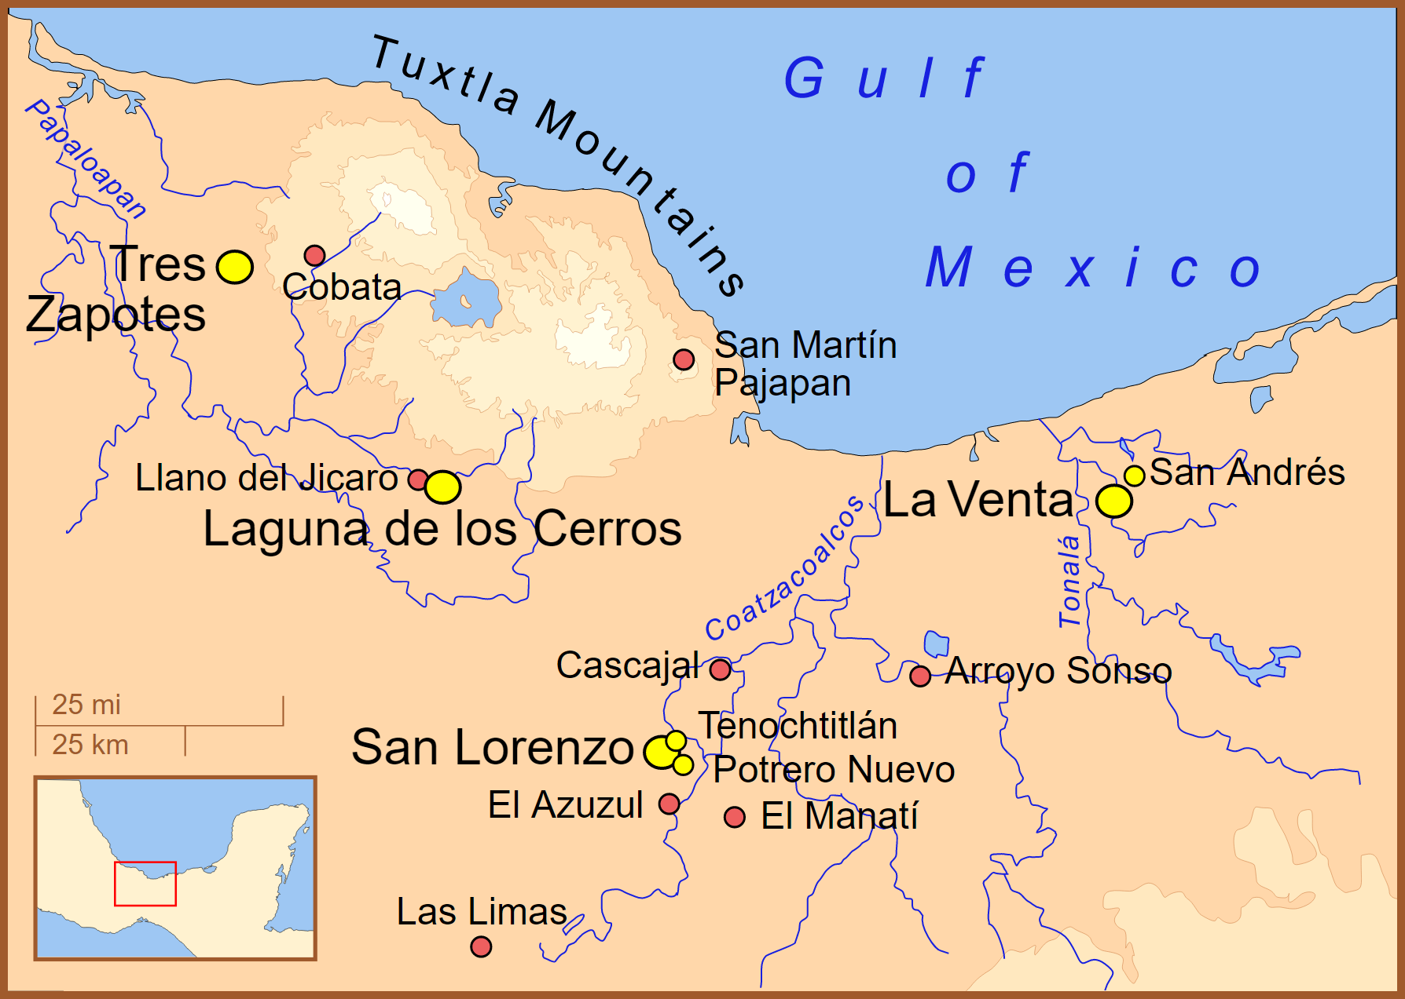 | It is located in the Valley of Mexico right in the middle of the country, settled in the old Tenochtitlán more accurately it was founded over a lake.
Foundation | Founded by the Aztecs with the name of Tenochtitlan.
Typical celebration | There is a parade on “Día de Muertos” in which volunteers rehearse choreographies and dress up as skeletons.  https://www.google.com.mx/search?safe=active&dcr=0&site=imghp&tbs=sur%3Afmc&tbm=isch&sa=1&ei=r-4BWvBlzNmbAajTlOgP&q=desfile+dia+de+muertos&oq=desfile+dia+de+muertos&gs_l=psy-ab.3..0l10.72492.75811.0.75977.22.18.0.0.0.0.300.2756.0j2j9j1.12.0....0...1.1.64.psy-ab..10.12.2745...0i67k1.0.QXsjtq9USyM#imgrc=Uob3F2qpmLxWhM: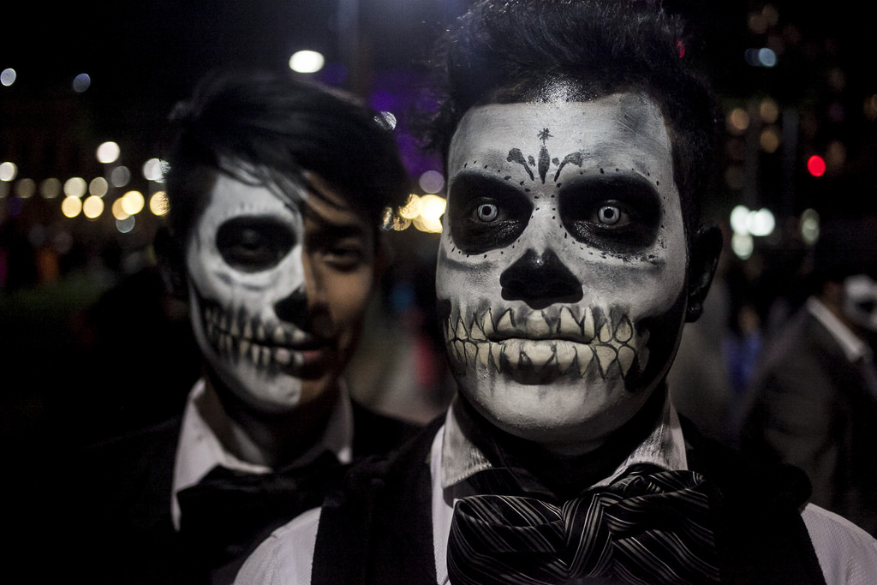 | There are many celebrations not only in the city but in all the country. In Mexico city one celebrations has became a recently but very beloved celebration. the death’s day parade which started as a movie scene for “Spectre” one of the movies of the James Bond Saga.  The parade was so beautiful that the city government decided to repeat it year after year to make it a new tradition.
Place to visit | Bellas Artes  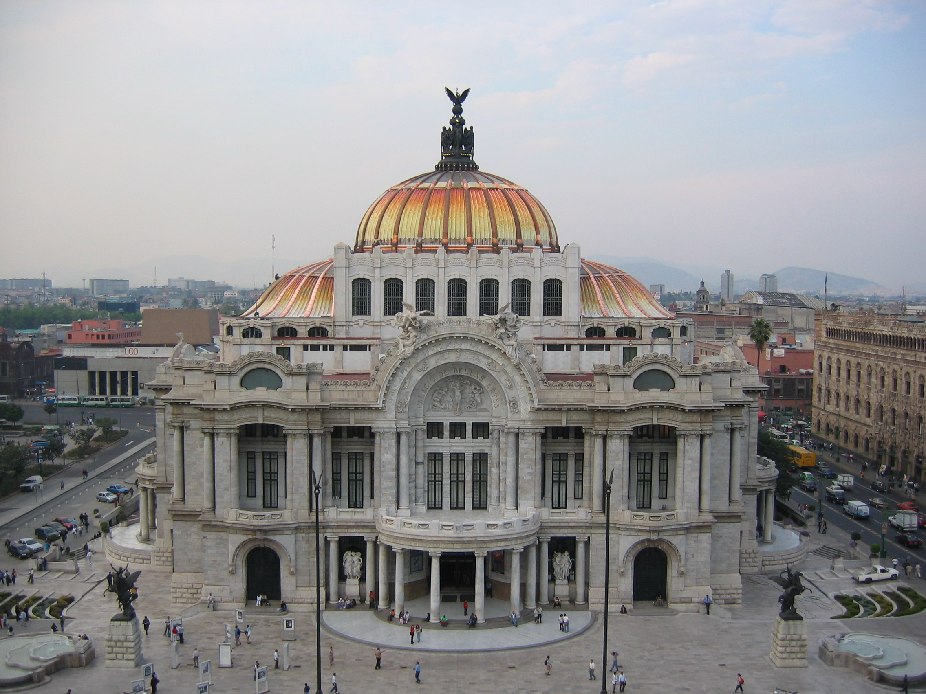  https://commons.wikimedia.org/wiki/File:Palacio_de_bellas_artes_1.jpg  Cathedral  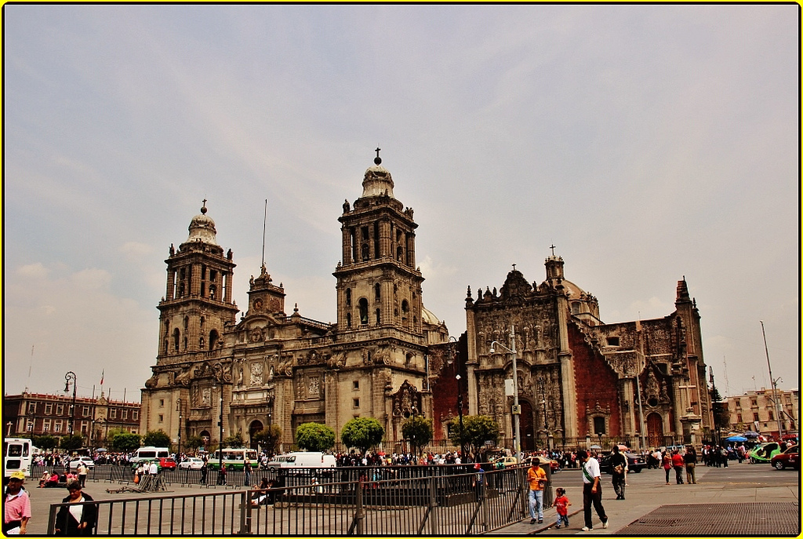  https://www.flickr.com/photos/eltb/8914345561  Antropology Museum  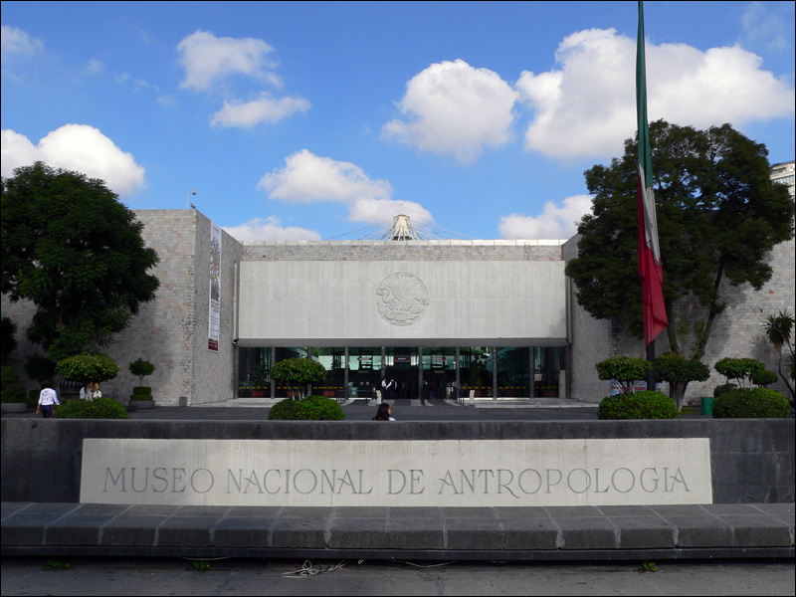  https://commons.wikimedia.org/wiki/File:Musee_National_Anthropologie-Entree.jpg  Coyoacán in the South of the city  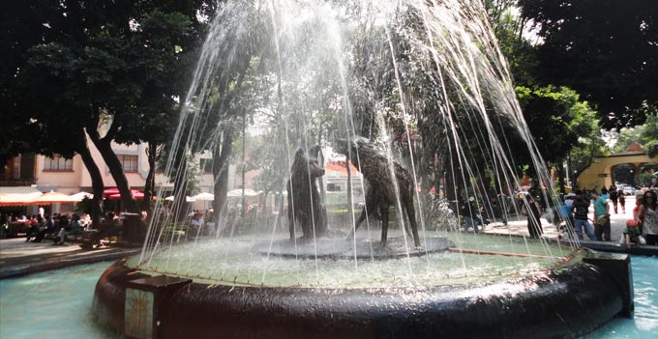  https://www.google.com.mx/search?safe=active&dcr=0&site=imghp&tbs=sur%3Afmc&tbm=isch&sa=1&ei=r-4BWvBlzNmbAajTlOgP&q=coyoacan&oq=coyoacan&gs_l=psy-ab.3..0l10.907.2136.0.2379.8.8.0.0.0.0.321.793.2-2j1.3.0....0...1.1.64.psy-ab..5.3.790....0.hyHBDl7sHJ4#imgrc=zZrgLlObICNfDM:  and of course Ciudad Universitaria  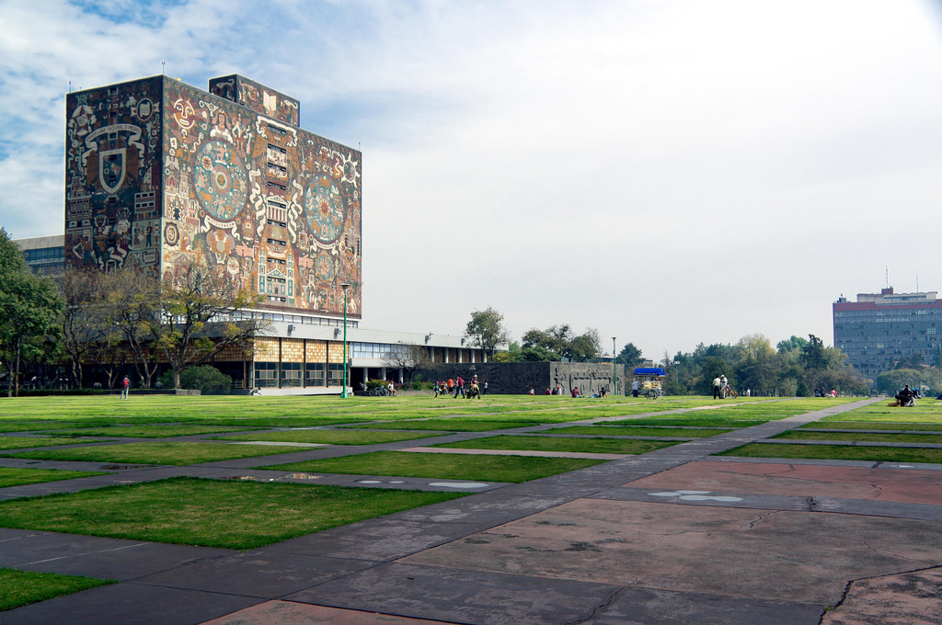  https://www.flickr.com/photos/coloboxp/6824754139 | Mexico is full of color and if you visit it be careful, because you will definitely fall in love with it. The architecture has no parallel and you can see it with your own eyes in the downtown of the city with great beautiful constructions such as Palacio de Bellas Artes or the Cathedral. Both building as a representation of the post revolutionary days and colonial architecture respectively.  But the fun does not stop there along Reforma Avenue you can find many museums like The anthropology museum where you can learn more about our origins.  If you like to have some traditional “antojitos” and to have a great time Coyoacan is definitely the option.  And of course the last place you have to see but in my opinion the most important. “Ciudad Universitaria” which is home of the University students from UNAM and even if your heart is not blue and gold (the official color of the university) it is impossible not to love this place.
City or Town | Mexico city  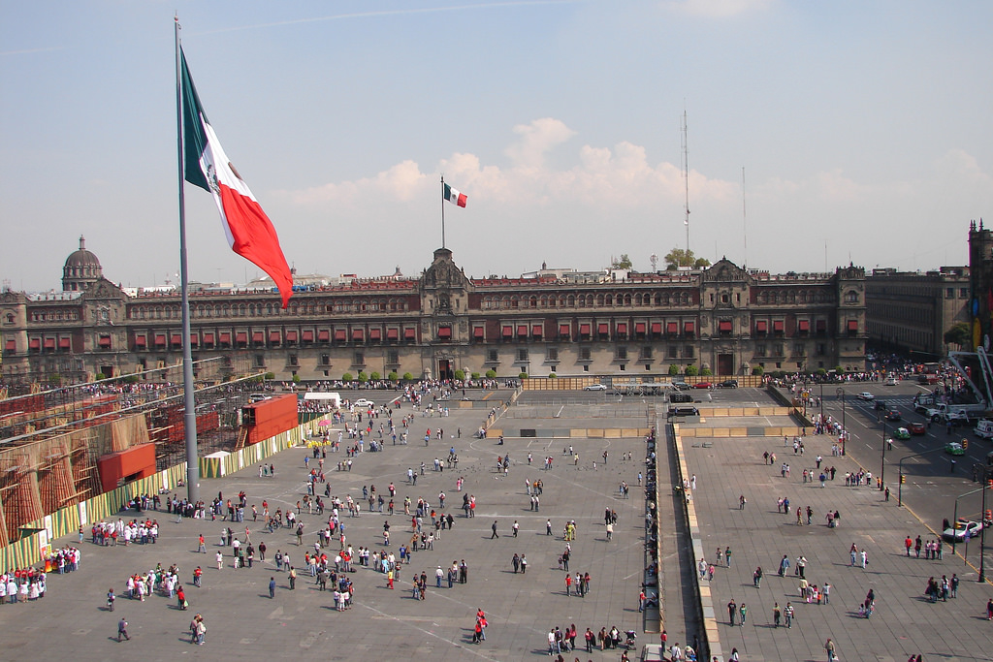  https://www.flickr.com/photos/antonystanley/2105552839
Typical Dish | Chilaquiles  https://commons.wikimedia.org/wiki/File:Portada-chilaquiles-rojos.jpg  Tacos al pastor  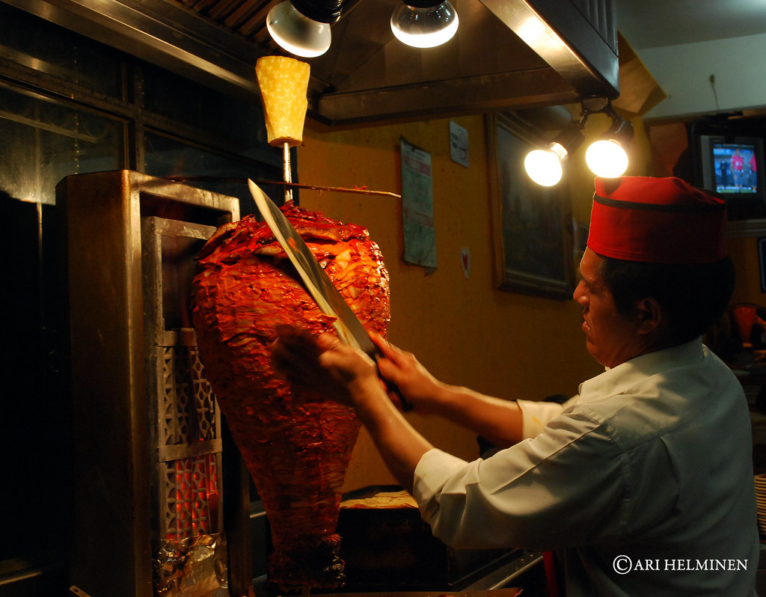  https://www.flickr.com/photos/picsoflife/4464404558 | Talking about food Mexico city has many options to offer. My personal favorite are the chilaquiles and tacos al pastor which can be found in almost every restaurant and street stand in the city. It is impossible to describe them you simply have to taste them.

